* + R programming codes and outputs
* **Note:** *These are illustrative chunks of codes that were executed to on datasets and similar queries were also executed on other monthly datasets.*

*#* **Importing Libraries**

**Note: All libraries has been imported successfully**

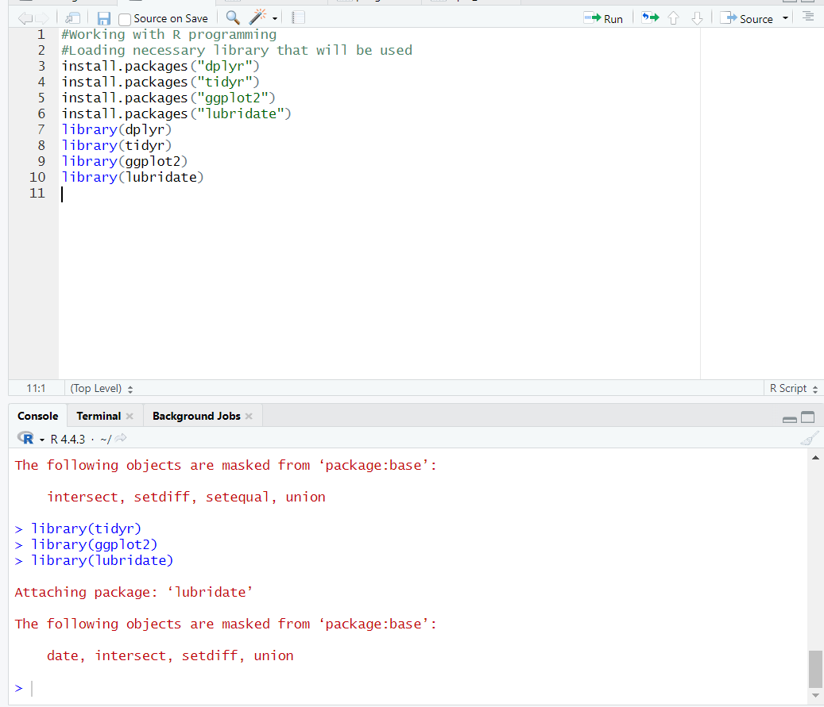

**# Inspecting and importing data to view**

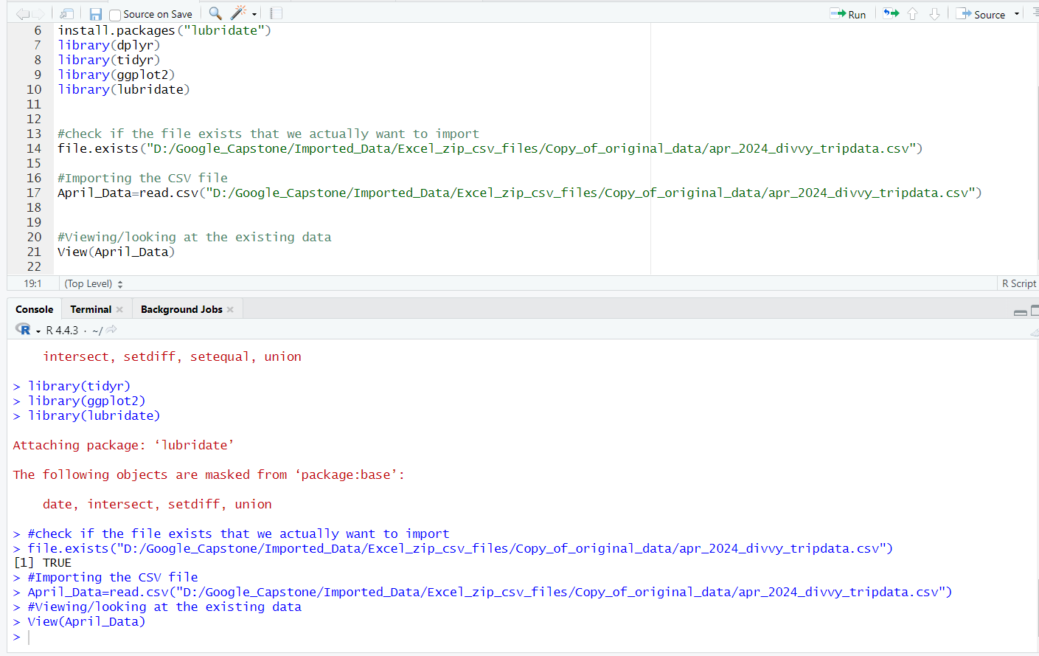

**# Imported Data**

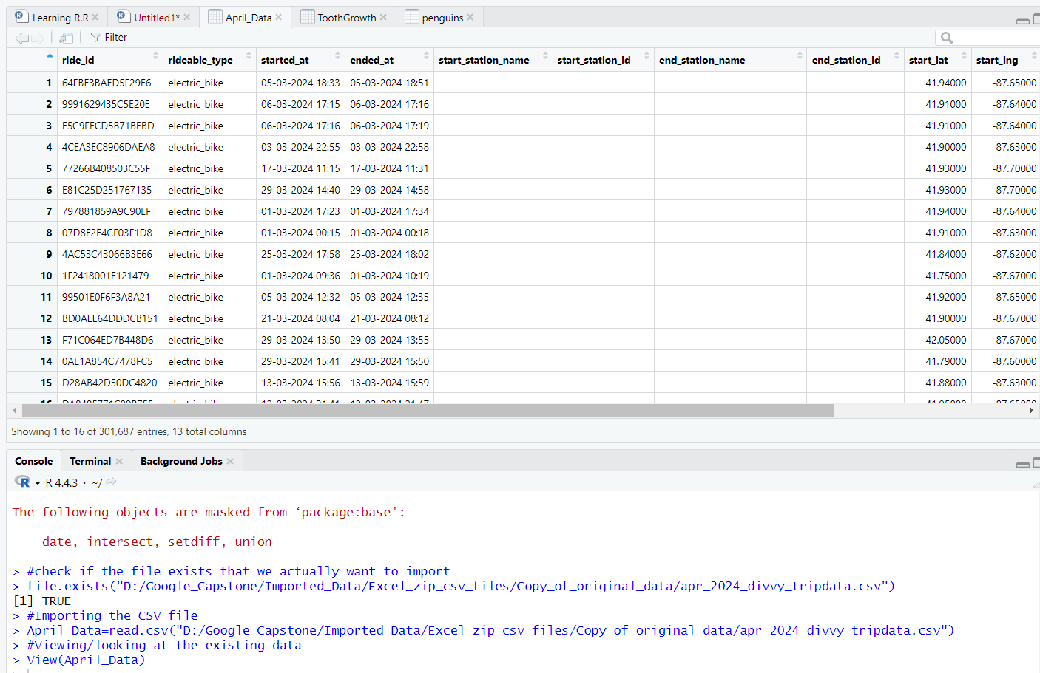

**# Looking at column names to avoid case sensitive errors and turning into dataframe**

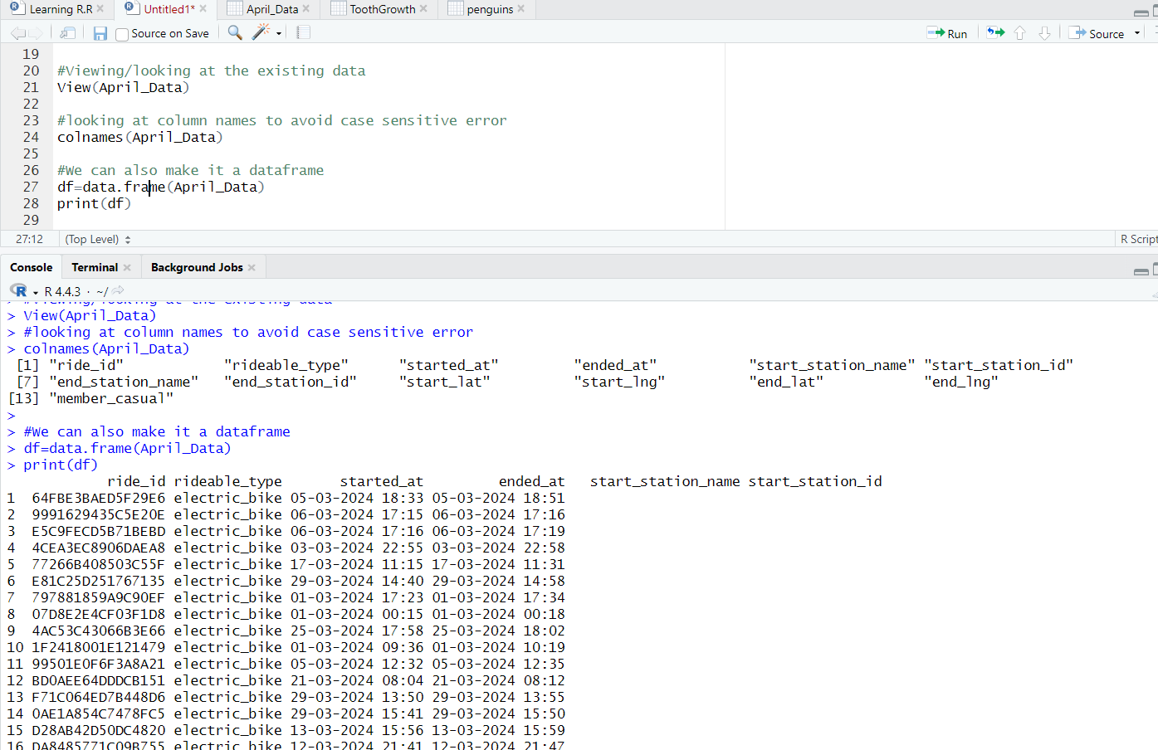

**# Handling missing values in certain columns**

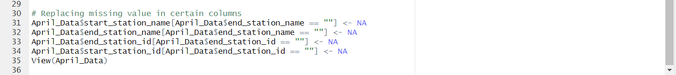

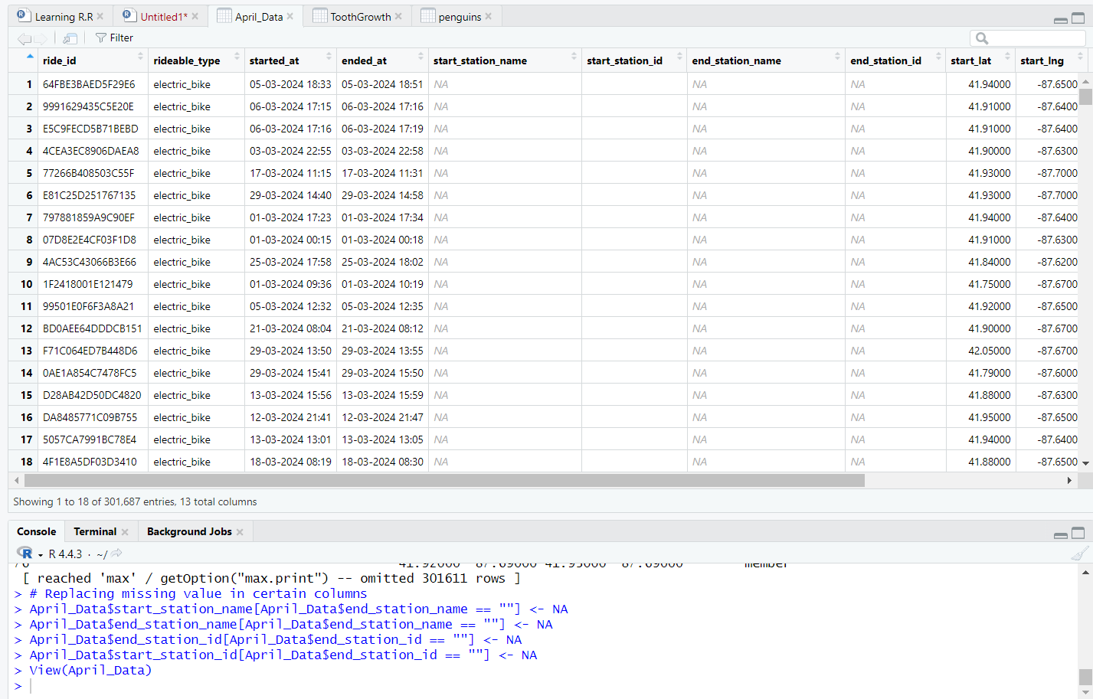

**# Overview of Data**

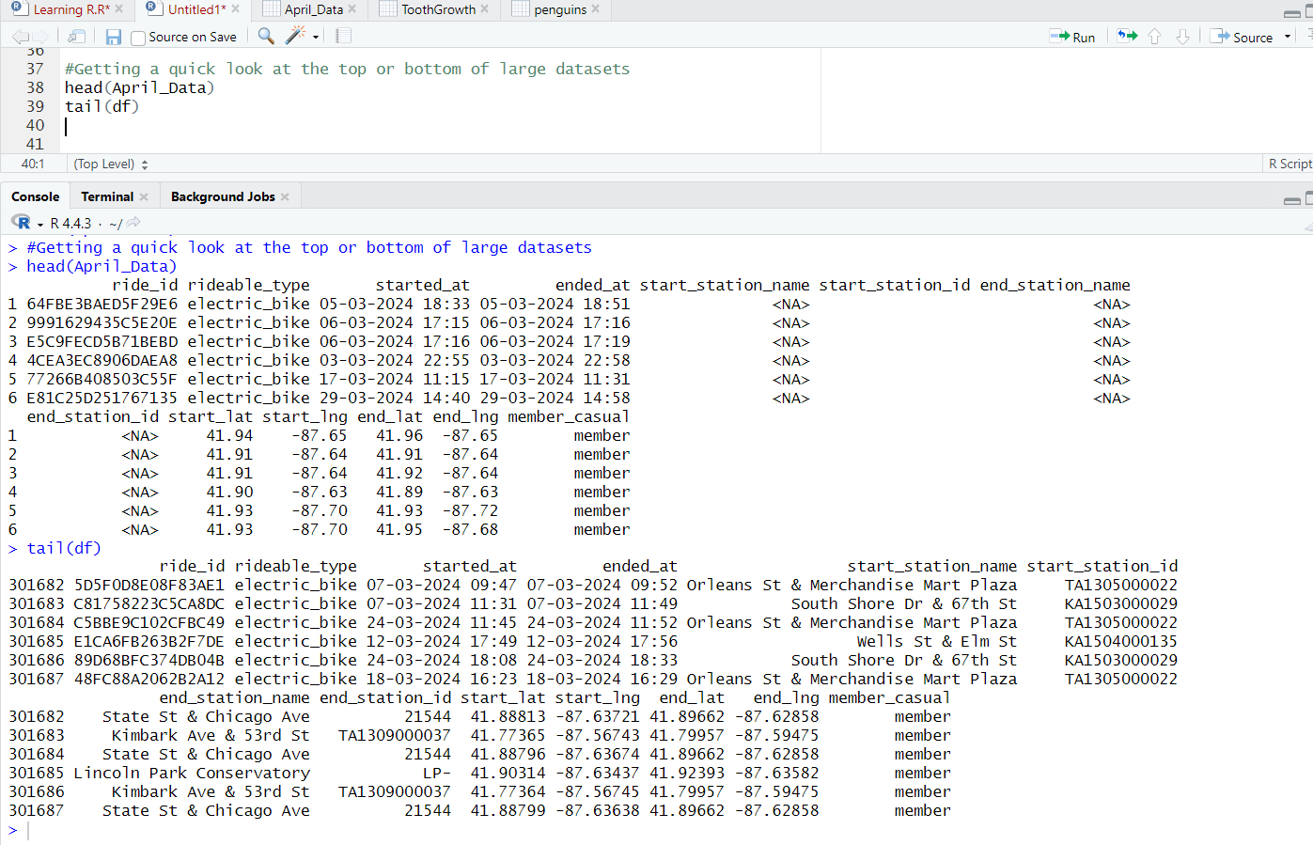

**# Counting the total number of people with casual and permanent members**

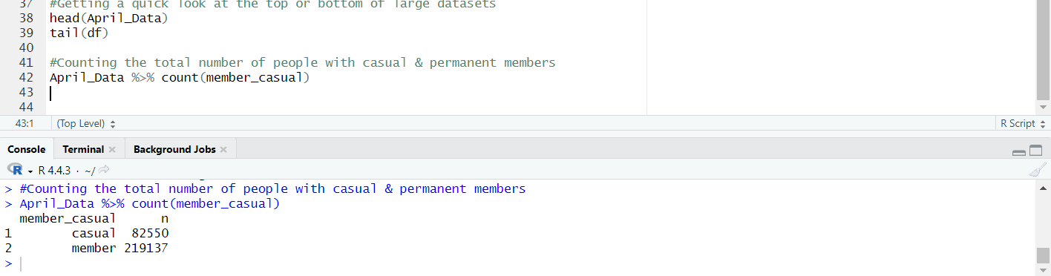

**# Count the total members using electric bikes**

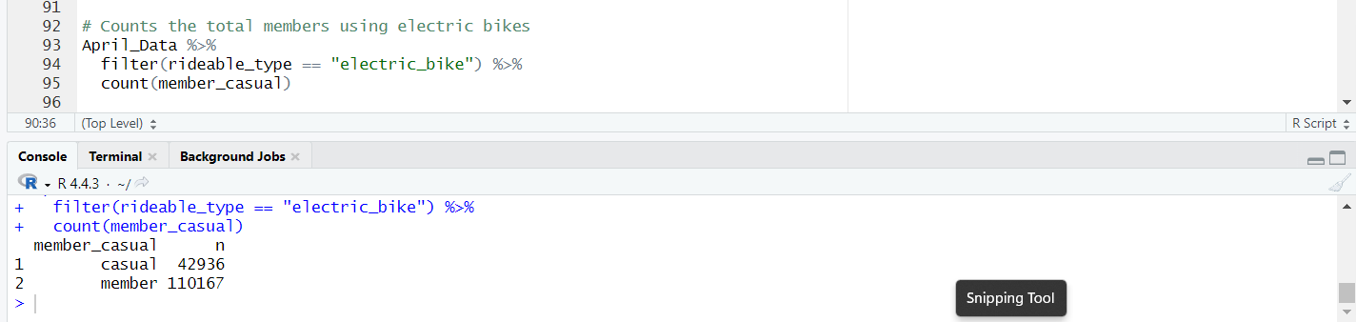

**# Separating time column to get better analysis**

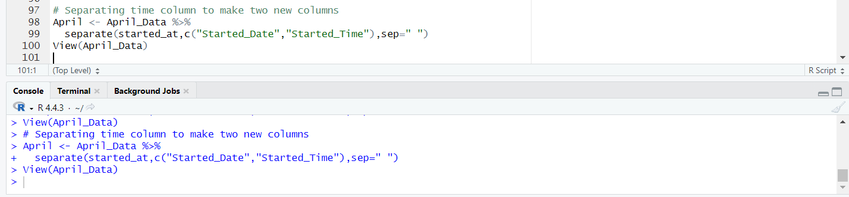

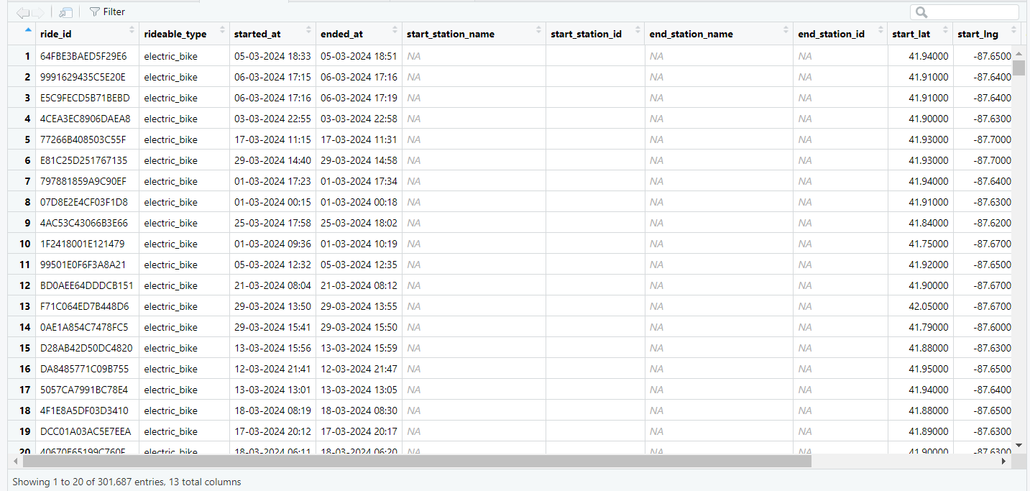

**#Other analysis**

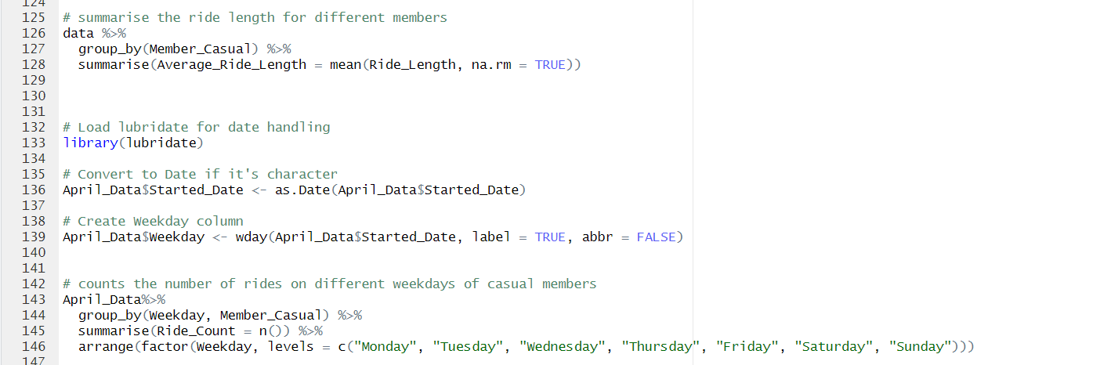

**#finding top end locations**

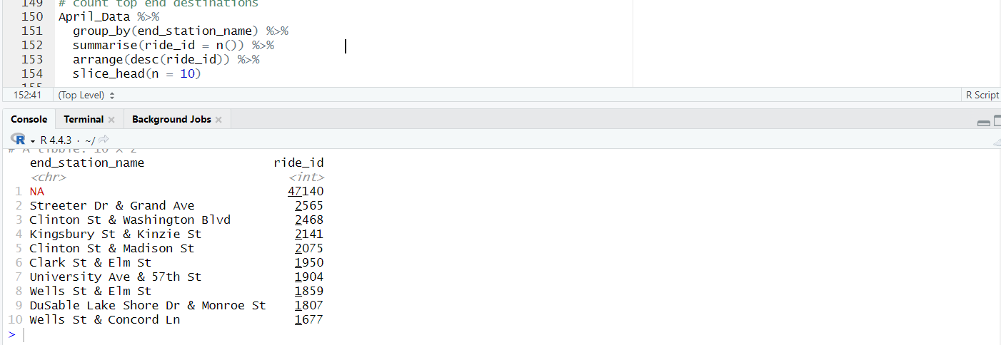

**Data Visualizations**

**# Comparing total rides**

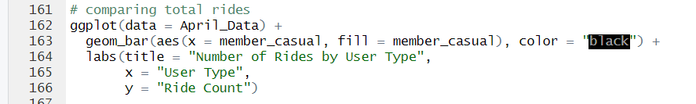

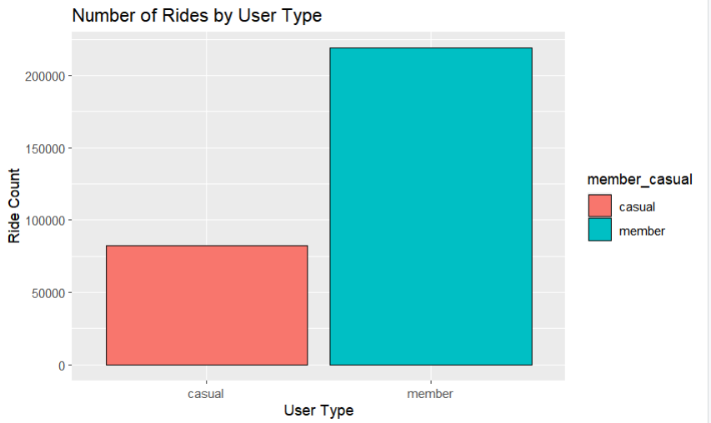

**# Total rides of users with different bikes**



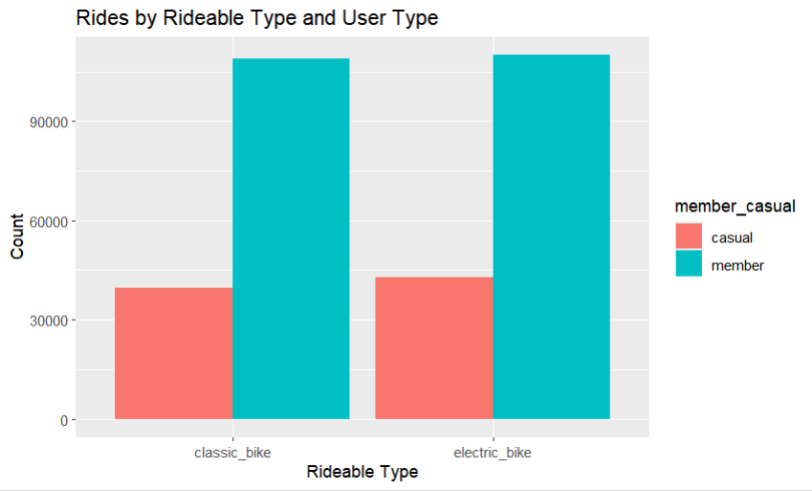

**# Top 10 end destinations**

